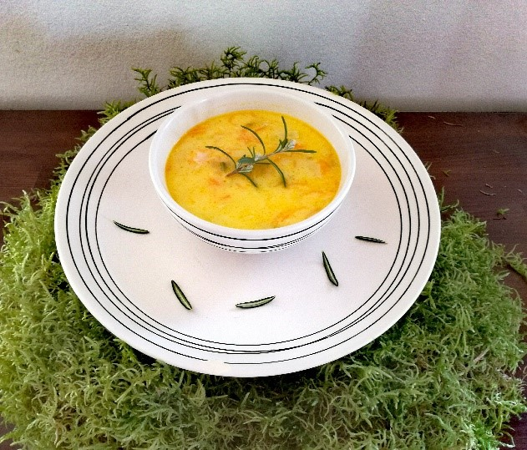
Fiskesuppe soup

Ingredients for 4 people:
- leftover salmon pieces
- 2 carrots
- 1 onion
- 2 cloves of garlic
- 1 leek
- 4 tbsp. of butter
- 4 tbsp. of flour
- 2 dcl of cream
- vinegar
- sugar

Prepare fish stock or water. Melt the butter in a pan and add garlic and onion. Slice the leek and grate the carrots. Add salt and pepper to the vegetables. Add the vegetables to the fish stock and boil for five minutes. Stir often so the vegetables cook evenly. Mix the flour with the cream, add to the soup and wait until it boils. Slowly add sugar and vinegar to your taste. There should be a balance between sweet and sour. Add salmon which you previously cut into smaller chunks and boil for about 6 to 7 minutes until the fish is cooked. Season with salt and freshly ground white pepper and sprinkle with finely chopped chives.

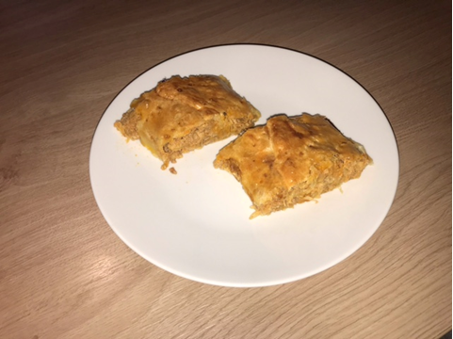
Sauerkraut and meat rolls

Ingredients:
- about 30 dag of sauerkraut
- 2 ladles of Bolognese sauce (leftovers from lunch)
- 1 packet of puff pastry sheets
- 1 bay leaf
- 1 egg

Boil a pot of water, add the bay leaf and sauerkraut and cook for about 20 minutes. Then strain the sauerkraut, cut it into smaller pieces and add the leftover Bolognese sauce. Put it back on the stove and let the excess fluid evaporate. Allow to cool. Beat the egg and add half of the egg to the sauerkraut and meat mixture. Spread out the mixture onto a sheet of puff pastry and then roll it up and carefully pinch the edges and seams closed. Use a fork to poke some holes into the roll and brush it with the rest of the beaten egg. Preheat the oven to 200 degrees and bake for about 45 minutes. You can serve sauerkraut and meat rolls with a bowl of your favourite salad.

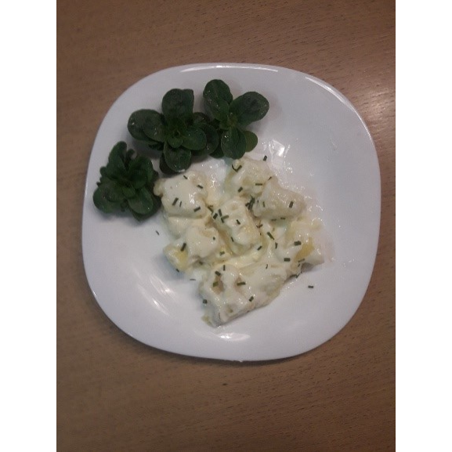
Gnocchi

Ingredients:
1 kg of leftover mashed potatoes
200 g of wheat flour
1 egg
1 tsp. of salt

Put the mashed potatoes onto a clean counter and make a well in the middle. Add the egg and salt and while mixing slowly add flour. Mix together with your fingers to make a soft dough that should not stick to your fingers.
We boil a big pot of water and add salt. On a lightly floured surface, cut small amounts of dough to form ropes and then cut into smaller pieces.
In a large pot of salted boiling water cook the gnocchi, gnocchi are ready when they float to the top.
Gnocchi can be served with a sauce or as a side dish.
If you make too many, you can store gnocchi for up to 1 month in the freezer. When you cook them there is no need to defrost, just add them to boiling salted water.

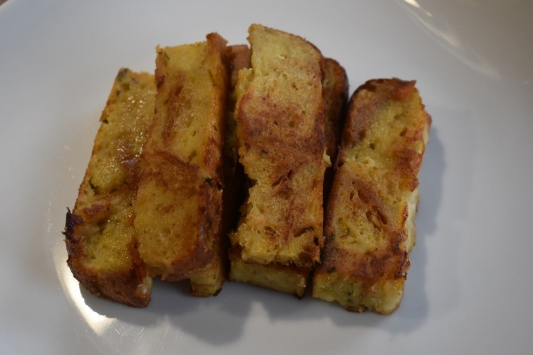
Bread casserole

Ingredients:
- 1/2 a loaf of stale bread
- 1 small onion
- 2 cloves of garlic
- 2 eggs
- 1 dcl of milk
- salt
- parsley
- 1/2 dcl of cooking cream
- cheese (optional)

Cut up the bread into smaller pieces, sauté the onion and garlic. Put the bread into a big bowl, add the sautéed onion and garlic and chopped parsley. Beat the eggs together with cooking cream and milk. Pour it over the bread. Add some salt and mix well. Put the mixture into a casserole dish, smooth it out and put some cheese on top (optional). Bake in the oven for 30 minutes at 180 degrees.

Potato omelette

Ingredients:
- leftover mashed potatoes (app. 2 potatoes)
- 1 egg
- 1 dcl od milk
- 1 1/2 tbsp. of flour
- a pinch of salt
- nutmeg
- 1/2 tbsp. parsley
- 2 tbsp. of parmigiana cheese
- pepper
- diced ham

Mix the egg and mashed potatoes first and then add the rest of the ingredients. Put some olive oil into a heated pan and pour in half of the mixture. When it is golden brown, turn it over like a pancake. Before serving sprinkle with some parmigiana cheese and parsley.

